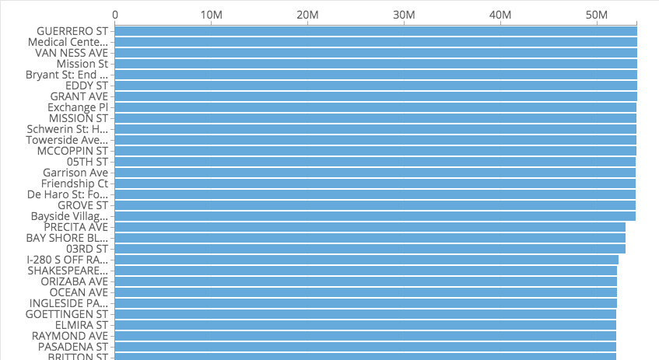

The above bar chart indicates that the Top 5 streets with maintenance treatments are :

* Guerrero St
* Medical Center
* Van Ness Ave
* Mission St
* Bryant St

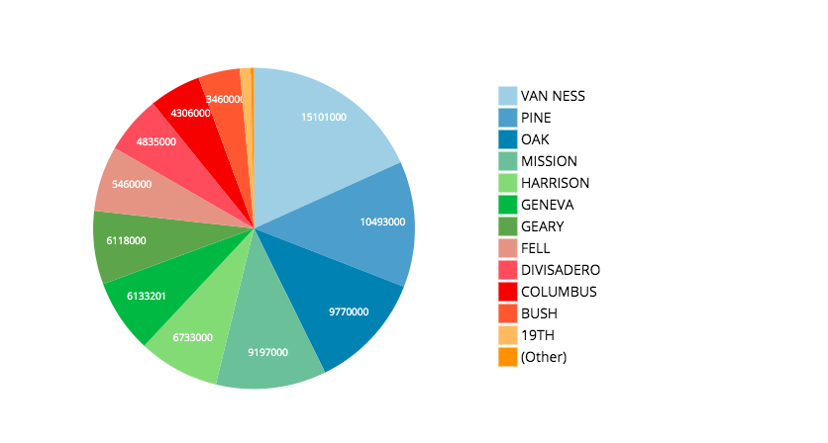

Above the Pie Chart shows the Top 5 Rush Hour Routes with the most traffic :

* Van Ness Ave
* Oak
* Pine
* Mission St
* Harrison

In conclusion with the data provided , 2 of the top 5 rush hour routes ( Van Ness Ave , Mission St) show that Street Maintenance is heavy in the same area as traffic is . Which concludes that it may play a factor as to why traffic can be congested in these 2 streets in San Francisco .